Notes:

Mission Team Schedule:
• Sunday, June 25 - Myron will preach Sunday morning and Sunday afternoon
• Monday, June 26 - Medical Clinic in San Salvador.
• Tuesday, June 27 - Shopping and walking to a tourist place.
• Wednesday, June 28 - Children's special service in Cojutepeque or 3rd Medical Clinic somewhere
• Thursday, June 29 - Fly home

Please take time to pray every day for this trip.
Enroll Today!!!
You can choose for PFWC to receive funds from Kroger and Amazon just because you shop there! We donate Kroger rewards to missions and Amazon rewards go towards facility repairs. Please make sure you are currently enrolled. This last quarter we received a check for $ 394.23. This brings our total from Sept. 14, 2015 – Mar. 30, 2017 to (drum roll) $ 5,227 from Kroger. THANK YOU to the families who have registered! It’s making a difference!
https://smile.amazon.com/ch/54-1016797

Sunday Worship
Blended Service - 9:30 AM
Contemporary Service - 11:00 AM
Connect and Grow Groups
9:45 AM & 11:00 AM

Wednesday Fellowship
KidZone (PreK-5th) & Epicenter Youth (6th -12th) 6:30 PM
Adult Power-Up 6:30 PM

*If you were signed up to have automatic withdrawals for online giving be sure to renew for this year!*

Offering 6/18
Tithes & Offering $ 2,189.00
Online Giving $ 101.55
Total $ 2,290.55

Other Giving
Missions Trip $ 1,706.13

Needed Weekly $4,175.02

Myron Atkinson, Lead Pastor – 540-556-3381 Cell
Darren Chilson, Assistant Pastor – 704-685-3988 Cell
Paul MacGregor, Children’s Pastor – 540-520-6892 Cell
3735 Chaparral Dr. www.pfwc.net 540-772-9482

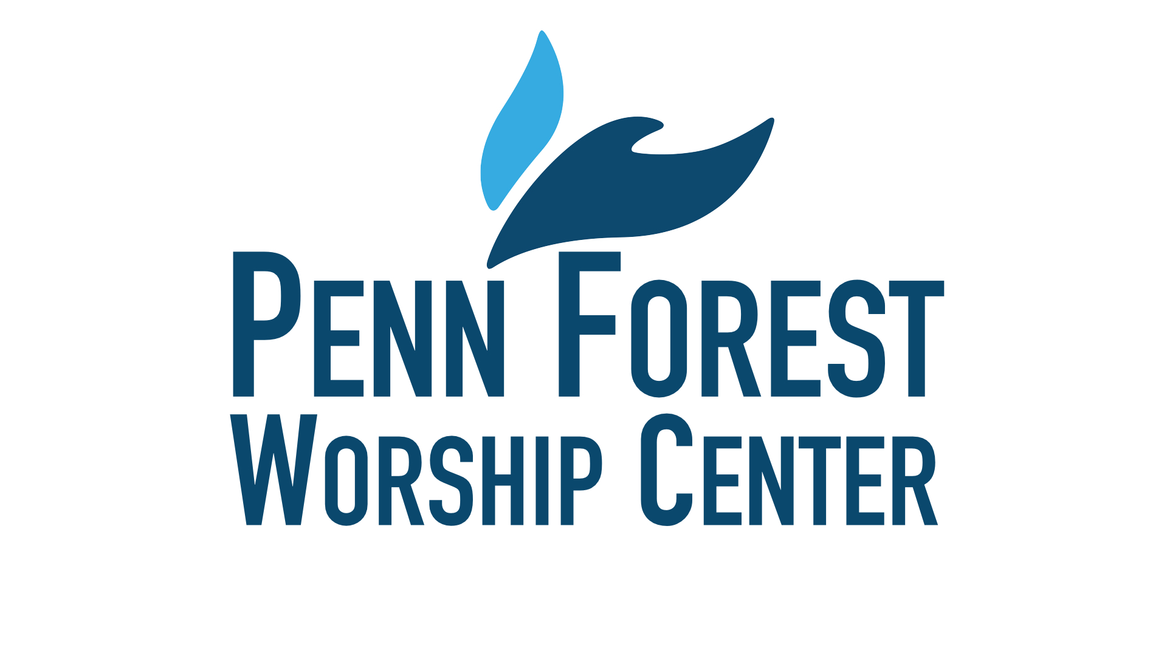

J u n e . 2 5 . 2 0 1 7
Is this your first time being with us at Penn Forest? If so, we are honored that you have chosen to worship with us today! Please fill out a connection card, and take it to the Welcome Center to receive a free gift. In doing so we can better serve you. Thank you for choosing to worship with us! It is our prayer that you will sense God’s presence here and receive a warm welcome.

Join us for this 3-sermon series dealing with our fear of end times. We will be dealing with fighting for something bigger than ourselves, the fear of death and the fear of the book of Revelation.
Membership
If you are renewing your membership, please turn your Reaffirmation letter today. If you would like to become a member, you will need to meet with Pastor Myron or Pastor Darren. We will begin receiving new members July 2nd. Reaffirmation and New Membership letters are available at the Welcome Center.

Join us today at 1:30 PM as we lead worship at Cave Spring Place located next to Advance Auto on Brambleton.

Family Picnic
Get ready for sack races, tug of war and more! The entire church is invited out for an Old Fashion 4th of July picnic with hot dogs, hamburgers, watermelon and more!

It’s been four years since we resealed the parking lot. It is definitely starting to show the wear and cracks are forming. In order to protect the parking lot and save a larger expense of having to resurface it, we are having the parking lot cracks filled and the entire parking lot resealed. The company we are using comes with good references and will be putting 2 coats of sealer on the parking lot and resealing it. The cost is expensive, however, it is considerably less than any of the other quotes that we received. They have given us a very good price because we are a church and the owner knows Ray Oyler. The repairs will be done July 5th – 7th and will cost $3,150.00. If you’d like to partner with us by giving above and beyond your tithes and offerings please go to www.pfwc.net and choose the “give online” link, then select Improvement Fund. Thank you for your sacrificial generosity!

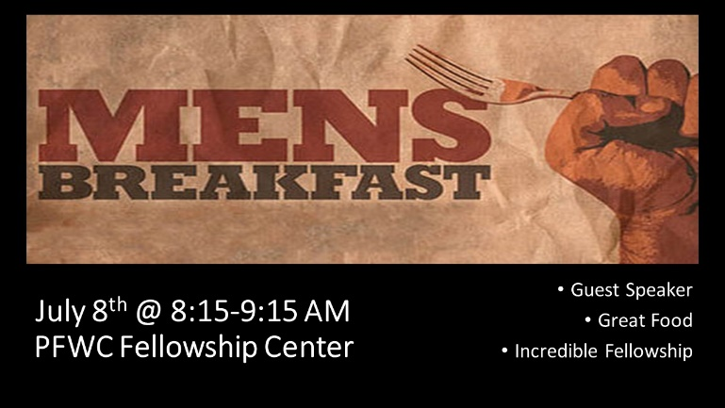
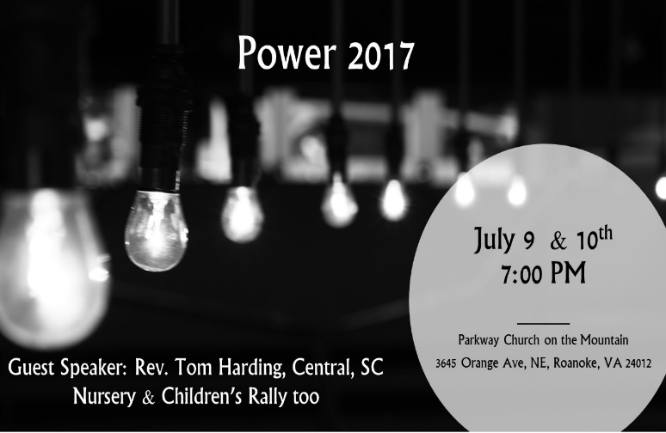
Attend these high-energy evening rallies that wrap around the annual daytime Shenandoah District Conference and are planned for all ages.
You will love them! Bring the whole family!

Times and Dates:
July 9 - 7:00 PM, Sunday Evening Rally
July 10 - 7:00 PM, Ordination Service
July 10 - 8:45 PM, Ordination Reception

Location: Parkway Wesleyan Church
3645 Orange Ave, NE
Roanoke, VA 24012
Featuring Excellent Speakers and Musicians!

Men’s Ministry
Our Tuesday Morning men's ministry is transitioning. We will still continue to meet but during the summer we will only meet on 7/18, 8/8, and 8/22. After summer we will meet twice a month at 6 AM at our regular time, but also schedule a second alternative time for those who can't make it. Watch for more info. We will begin going through the book "Act Like Men" by James MacDonald.

